Rock Solid Series - Gospel of John
4 Questions for the passage (self-study):
What is God teaching us about Himself?
What is God teaching us about our self?
What is God teaching us about others?
So what?

[Cite your source here.]
Ch 1-2- Discover Truth, Ch 3-4 – Ask Questions, Ch 4-5 Build on Evidence

Start Right & Finish Strong – Deepen Your Faith

“But these are written that you may believe that Jesus is the Messiah, the Son of God, and that by believing you may have life in His name.” 20:31
August 7, 2022 – Pastor Matt

July 17 – God has a plan
July 24 – Maturity looks beyond self-interest
July 31– Luke
Aug 7 – Be a “No-Fail” Follower
Aug 14 – Dig Deep
Aug 21 – Why is it so hard to believe

Focus Text: John 6:60-71

Introduction:
- Will a “No fail” follower sin – YES - A “No Fail” follower will NOT QUIT
- The strength of a person/relationships is seen in what it takes to STOP them – people quit – God doesn’t
Personal Insights:

A “No Fail” follower will WRESTLE
- Wrestling with the teaching of Christ is not a ONE-TIME experience
- Crisis REVEALS the commitment
Personal Insights:

A “No Fail” follower will DECIDE
- What are the ALTERNATIVES?
- Can you trust YOURSELF?
- Can you trust another TEACHING?
Personal Insights:

A “No Fail” follower will GROW
- Experiences and challenges to our faith create a CONTEXT to grow
- Growth is the result of being SETTLED
- John calls for DECISIVENESS in commitment
Personal Insights:

Every person must personally decide – What will I do when the going gets tough – Hard times are coming for the Church in America – If what you are living for is not worth dying for it is not worth living for! Commit to follow Jesus with me!

SO What – NOW What
Tasks to be done later – write them down, leave them, and get back to the message!

Prayer Concerns:

Notes for Personal Study:

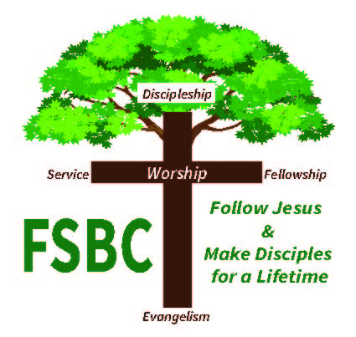

SERMON NOTES
The Church that Jesus commissioned is a Church that must be a Disciple-Making Church! The Bible shows a disciple is one who has encountered Christ, been changed by Christ and is following Christ with other believers.
I see the Sunday message as one part of the disciple-making process, so I am intentional with sermon notes. Please note:
- The blanks that are provided are intended to provide a framework for God’s message to you.
- The personal insight blanks are intended for you to reflect on what God is saying to you.
- The sermon notes and your notes are intended for us to move through an intentional, discipleship process.
I pray today’s message strengthens you in your walk with Jesus and the overflow impacts others!
Pastor Matt
even though they “heard” (akouein) Jesus, they failed to “accept” (akouein) the word (logos) of Jesus. The wordplay here is important because it reminds the reader that the mere hearing of words is not enough. It is “obedience,” the implied meaning of akouein
The Gospel of John is a book that calls for decisiveness in Christian commitment
Passover is marked by the death of the lamb, and the disciple is one who receives Jesus and is marked by his death
pseudobelieving (cf. 2:23–25
This chapter is brought to a close with the theme of rejection. Those disciples who found it hard to stomach the claims of Jesus in fact joined the opponents by withdrawing from Jesus. They were no longer willing to walk alongside him (peripatein, the word used to epitomize discipleship
This confession in the Fourth Gospel is parallel to the confession of Peter at Caesarea Philippi in the Synoptics (cf. Matt 16:16; Mark 8:29; Luke 9:20),
It does not mean “hard to be understood,” but difficult to accept or be content with
their unwillingness to accept the bloody death of their Messiah, or to entrust themselves to a Divine Personality whose most distinctive act would be his sacrifice. This was the gross and terrible offence which made the cross a stumbling-block to the Jew (see ch. 12:34; 1 Cor. 1:23; Gal. 5:11; Matt. 16:21, etc.).
But these are written that you may believe ^{x} that Jesus is the Messiah, the Son of God, and that by believing you may have life in his name

But these are written that you may believe ^{x} that Jesus is the Messiah, the Son of God, and that by believing you may have life in his name

Gerald L. Borchert, John 1–11, vol. 25A, The New American Commentary (Nashville: Broadman & Holman Publishers, 1996), 274.
Gerald L. Borchert, John 1–11, vol. 25A, The New American Commentary (Nashville: Broadman & Holman Publishers, 1996), 274.
Gerald L. Borchert, John 1–11, vol. 25A, The New American Commentary (Nashville: Broadman & Holman Publishers, 1996), 274.
Gerald L. Borchert, John 1–11, vol. 25A, The New American Commentary (Nashville: Broadman & Holman Publishers, 1996), 275.
Gerald L. Borchert, John 1–11, vol. 25A, The New American Commentary (Nashville: Broadman & Holman Publishers, 1996), 275.
Gerald L. Borchert, John 1–11, vol. 25A, The New American Commentary (Nashville: Broadman & Holman Publishers, 1996), 275.
H. D. M. Spence-Jones, ed., St. John, vol. 1, The Pulpit Commentary (London; New York: Funk & Wagnalls Company, 1909), 271.
H. D. M. Spence-Jones, ed., St. John, vol. 1, The Pulpit Commentary (London; New York: Funk & Wagnalls Company, 1909), 271.

